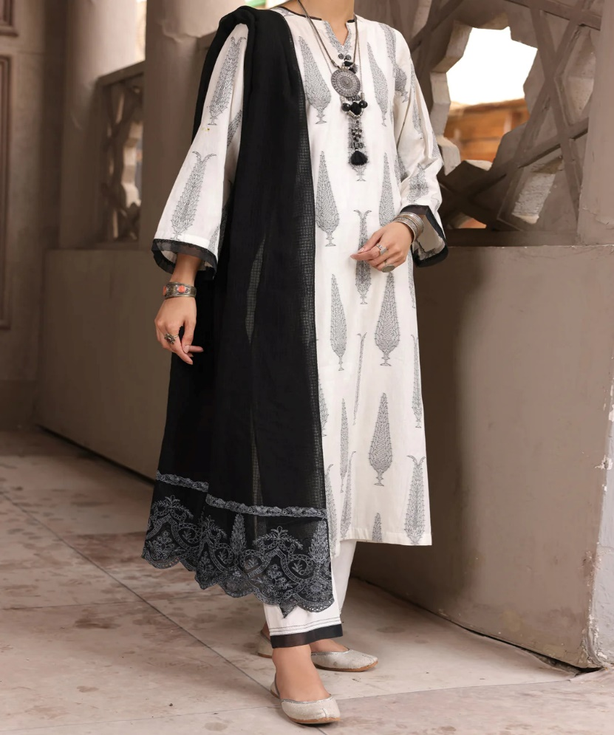

# BLACK & WHITE JACQUARD 3 PIECE

priceRs.5,895.00

ADDITIONAL INFO

|  |  |
| --- | --- |
| **Color** | Black & White |
| **Pieces** | 3 Pieces |
| **Fit Type** | — |
| **Fabric** | Jacquard, |
| **Season** | Festive Collection |
| **Disclaimer** | Due to the photographic lighting & different screen calibrations, the colors of the original product may slightly vary from the picture. |